Homework for week 7

Linzi Zhang (liz93@pitt.edu)

1.  How many edges are on 7 dimensional hyper-tetrahedron?  How many edges in a 7 dimensional cube?

7 dimentional is $K_{8}$ has C(8,1)=8 vertices and C(8,2)=28 edges.

C(7,1)*=448

2.  How many 4 dimensional cubes are in a 9 dimensional cube?

C(9,4)*=4032

3.  What is the volume of a 5 dimensional sphere of radius 2?

 

n=5, r=2

=π

(2)=

4.  download the dataset from http://archive.ics.uci.edu/ml/datasets/Wine OR type **[d lab]=wine_dataset** ; into MATLAB

  a.  Create a multiple scatterplot on the 13 variables

plotmatrix(B)

  b.  Use pca in MATLAB to find the first two principal components

pc=pca(B);

pc2=pc(:,[1 2])

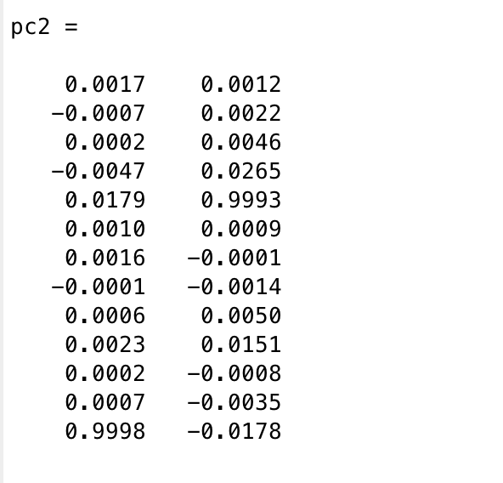

  c.  Project the data onto the two PCs, and plot a scatter plot

C=B*pc2

scatter(C(:,1),C(:,2))

